CS386 Hardware Installation



GROUP 16

Project: GESTURE CONTROLLED ROBOT

The objective of this document is to help someone else run the code that is delivered as part of this project.

**Project Title:** TENNIS BALL COLLECTOR ROBOT

**Students:**

|  |  |  |
| --- | --- | --- |
| Name | Roll No. | Email |
| ANUP NAIK | 10305915 | [anupnaik@cse.iitb.ac.in](mailto:anupnaik@cse.iitb.ac.in) |
| VISHNU KANTH T | 10305020 | [tvishnu@cse.iitb.ac.in](mailto:tvishnu@cse.iitb.ac.in) |
| RAJ DEEPAK P | 10305081 | [rajdeepak@cse.iitb.ac.in](mailto:rajdeepak@cse.iitb.ac.in) |

**PROJECT OBJECTIVE**

The aim of the project is to program the firebird to collect tennis balls scattered in a court.

**HARDWARE PLATFORM**

1. Firebird V ATMEGA2560 (Cost=Rs.16,875.00)
2. Zig-bee (XBee 802.15.4 OEM RF module 2.4GHZ) is used for communicating between the firebird and PC (Cost = Rs.1665).

**EXTENSIONS USED**

1. A gripper is attached to the firebird for collecting the ball. Three servo motors are used for this. Two servo motors are used for upward and downward movement of the gripper and one is used for opening and closing the arms of the gripper.

1. Thermocol attachment is placed in front of the robot to place camera and the two sharp IR sensors used.

**SETUP AND EXTENSIONS ON THE ROBOT**

The gripper is a small attachment made of plastic, thermocol and servo motors for gripping the ball. The image of the gripper is shown in the figure below.

Materials required for making gripper are:

* Two toothed gear wheels.
* Plastic strips.
* Thermocol.
* Metal strips for holding the two wheels together.
* Three servo motors.

**p**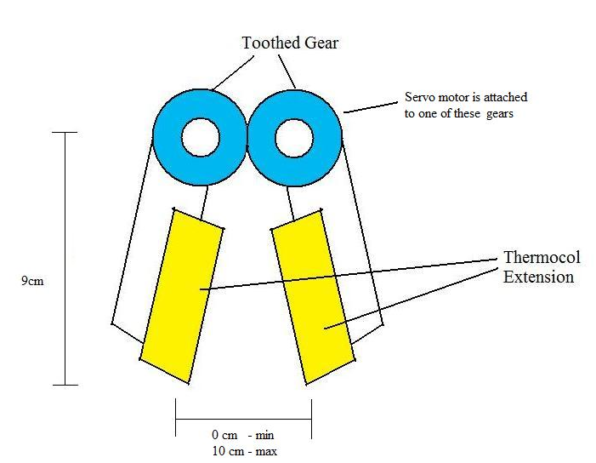

Plastic Strips

Fig. Diagram of gripper.

Two arms of the gripper are attached together using a gear arrangement. A servo motor is connected to one of the gear wheel. When this servo motor rotates, both the arms move due to the presence of gear wheels. A thermocol attachment is provided on the gripper for better catch. Actual photo of the gripper is shown below.

The setup of gripper arm thus obtained can be fixed to the firebird at points where screws are provided using metal strips.(You might have to bend the metal strips (if bent ones aren’t available) so as per need)

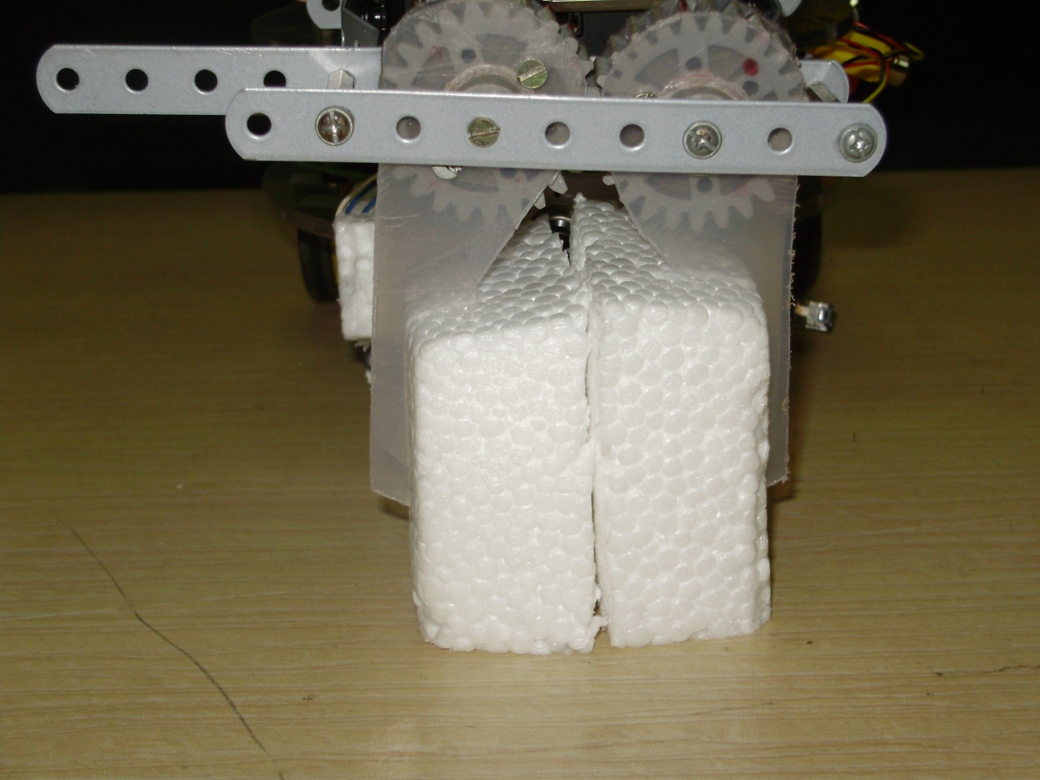

Plastic Strips

Thermocol

Metal strips

Fig. Photograph of gripper.

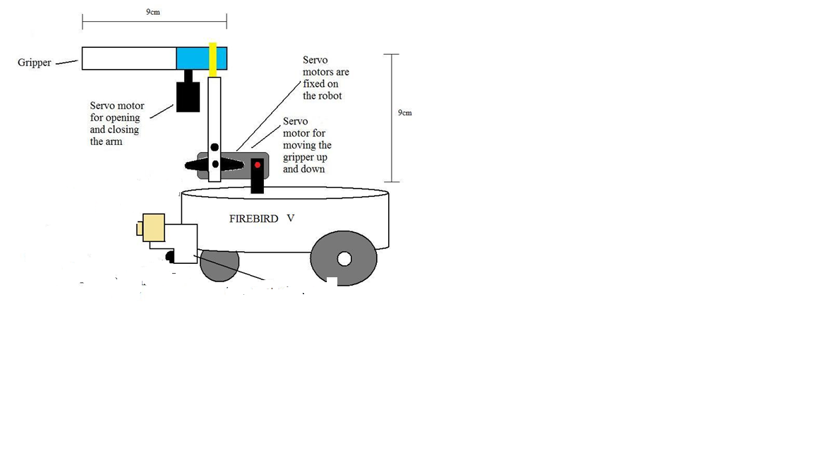

Fig. Diagram of tennis ball collector robot

The actual photo of the robot is given below.

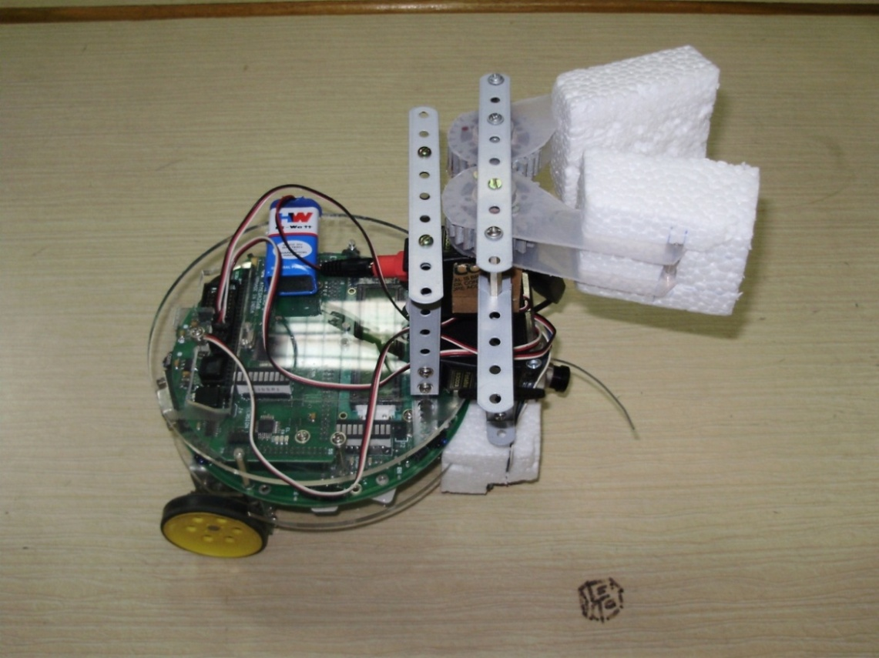

Fig. Photograph of tennis ball collector robot

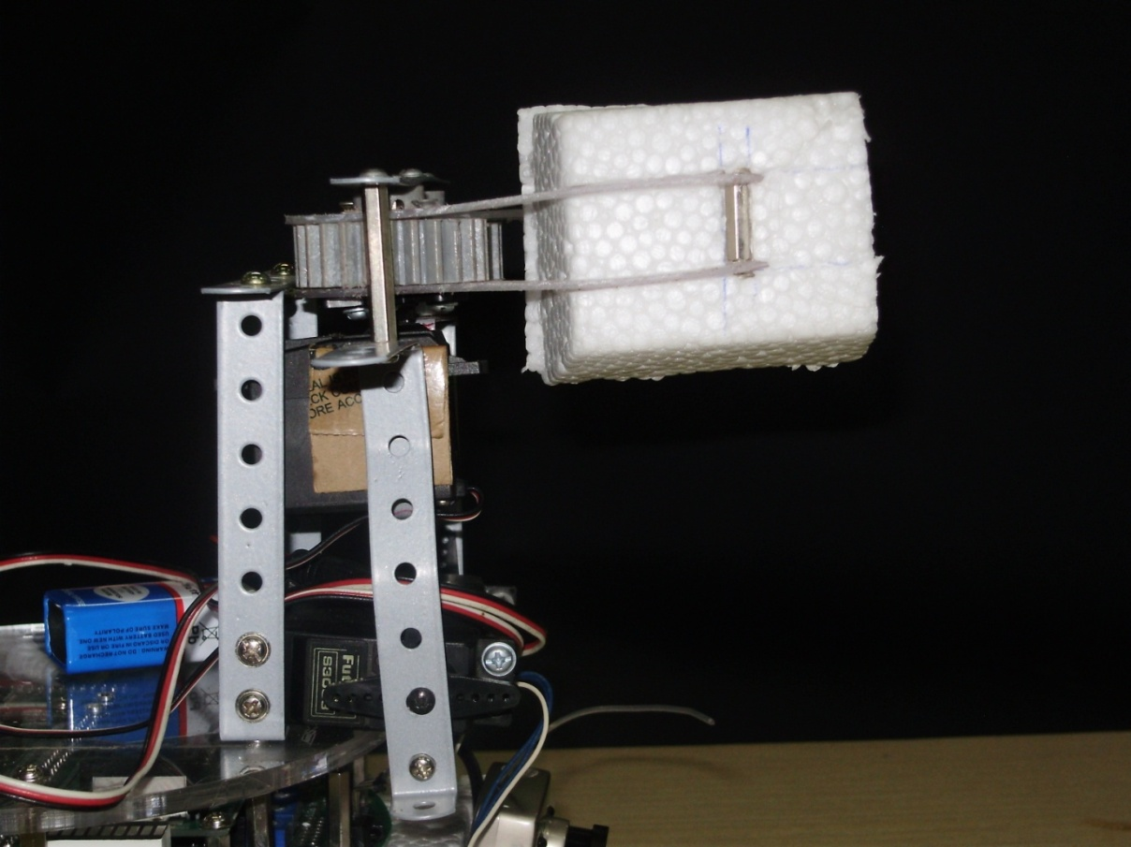

Fig. Gripper arm side view (Idle position)

**Zigbee Module Configuration:**

The detailed procedure as to how you can configure your zigbee module is provided in the e-yantra website under the tutorials section.